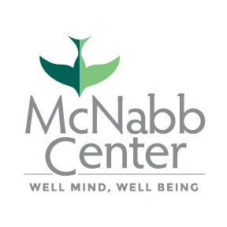**PRESS RELEASE**

Contact: Jessica Hill

Director of Community Relations [Jessica.hill@mcnabb.org](mailto:Jessica.hill@mcnabb.org)

(865) 599-5836

# October 15, 2021

McNabb Center awarded funding to develop & enhance programming for   
children experiencing mental health crisis

(KNOXVILLE, Tenn.) The McNabb Center was awarded a Community Mental Health Services Block Grant to address a gap in children’s crisis services in the Knoxville area. The Center will be using the funding to develop a Family Walk-In Center that helps children experiencing a mental health crisis avoid hospitalization and receive intensive services within their community.

“We know that the COVID-19 pandemic has intensely impacted the emotional wellbeing of children,” said Mary Katsikas, McNabb Center regional clinical vice president. “We are proud to offer a rapid response to children in crisis and believe it will fill a significant gap in our community.”

Nationally during the pandemic, child psychiatric visits to hospital emergency departments has increased 24 percent for children ages 5-11 and 31 percent for ages 12-17. At East Tennessee Children’s Hospital, emergency room visits for behavioral health issues have increased 20 percent.

This program will expand the McNabb Center’s full continuum of children and youth services. The program will provide 6-8 weeks of intensive outpatient services for children in crisis. The program will identify children in need through the Mobile Crisis Unit, referrals from area hospitals and other community agencies and organizations. In addition, families can self-refer to the Walk-In Center, which will be open 7 days a week from 8 a.m. – 8 p.m.

The McNabb Center was also recently awarded funding by the Substance Abuse and Mental Health Services Administration to enhance this children’s crisis continuum, which includes providing a crisis stabilization unit (CSU) specifically for children in partnership with East Tennessee Children’s Hospital. Children served through the CSU will be offered specialized outpatient services through the Family Walk-In Center.

The new children’s crisis program will open in early November 2021 and is located at 5645 Merchants Center Blvd., Knoxville, TN, 37912.

The McNabb Center is the region’s leading nonprofit provider of mental health, substance use, social and victim services. By focusing on an individual’s “*Well Mind, Well Being*,” we provide a quality and compassionate approach to care from infancy through adulthood. Since 1948, the Center has proudly served individuals with the most needs and fewest resources. Today, the McNabb Center delivers support to more than 30,000 people throughout East Tennessee each year. For more information, visit [www.mcnabbcenter.org](http://www.mcnabbcenter.org/) or call 1-800-255-9711.

# # #